AREA AND PERIMETER OF CIRCLE

CODE:-
import java.io.*;
class circle
{ publicstaticvoid main(String arg[])
{ int radius;
try
{ InputStreamReader In=new InputStreamReader(System.in);
BufferedReader br= new BufferedReader(In);
System.out.print("Enter the radius of circle = ");
String str= br.readLine();
radius= Integer.parseInt(str);
double area,perimeter;
area=3.14*radius*radius;
perimeter=2*3.14*radius;
System.out.println("Area of circle = " + area);
System.out.println("Perimeter of circle = "+perimeter);
}
catch(Exception e)
{ System.out.println("Error : " + e);
}
}
}

OUTPUT:-
Enter the radius of circle=3
Area of circle=28.26
Perimeter of circle=18.84

SUBSTRING REMOVAL
CODE:-

import java.io.*;
class subrem
{ publicstaticvoid main(String arg[])
{ StringBuffer str;
String substr,temp;
int strlen,i=0,ctr=0;
int substrlen;
DataInputStream din=new DataInputStream(System.in);
try
{ System.out.println("Enter the string : ");
str=new StringBuffer(din.readLine());
System.out.println("Enter the substring to be removed");
substr=din.readLine();
strlen=str.length();
substrlen=substr.length();
strlen=strlen-substrlen;
while(i<=strlen)
{ temp=str.substring(i,i+substrlen);
if(temp.equals(substr))
{ str.delete(i,i+substrlen);
strlen=strlen-substrlen;
ctr++;
}
else
{ i=i+1;
}
}
System.out.println(str);
System.out.println("number of substring removed"+ ctr);
}
catch(IOException e)
{ System.out.println(e);
}
catch(StringIndexOutOfBoundsException e)
{System.out.println(e);
}
}
}

OUTPUT:-

Enter the string:
Welcome to the game
Enter the substring to be removed:
Me
Welco to the ga
Number of substring removed:2

METHOD OVERLOADING
CODE:-
class overload
{ int p;
Void volume(int a)
{ p=a*a*a;
System.out.println("Volume of cube:" + p);}
void volume(int a,int b,int c)
{ p=a*b*c;
System.out.println("Volume of cuboid" + p);
}
Public static void main(String arg[])
{
overload b=new overload();
b.volume(5);
b.volume(5,10,5);
}
}

OUTPUT:-
Volume of cube:125
Volume of cuboid:250

MULTI-LEVEL INHERITANCE
CODE:-

import java.io.*;
class multilvl
{
int sid;
String sname,branch;
char year;
multilvl(int id,String sn,String b,char y)
{
sid=id;
sname=sn;
branch=b;
year=y;
}
void display()
{
String yrdetail=" ";
if(year=='f')
yrdetail="First Year";
elseif (year=='s')
yrdetail="Second Year";
elseif (year=='t')
yrdetail="Third Year";
System.out.println("\n\t\t\t The student details :");
System.out.println("Student id : " + sid);
System.out.println("Name : " + sname);
System.out.println("Branch : " + branch);
System.out.println("Year : " + yrdetail);

}

}
class mark extends multilvl
{
String category;
int mark1,mark2,mark3;
mark(int id, String sn,String b,char y,String cat,int m1,int m2,int m3)
{
super(id,sn,b,y);
category=cat;
mark1=m1;
mark2=m2;
mark3=m3;
}
void display()
{
super.display();
System.out.println("Category : " + category);
System.out.println("Mark1 : " + mark1);
System.out.println("Mark2 : " + mark2);
System.out.println("Mark3 : " + mark3);

}
}
class report extends mark
{
double total,avg;
String grade;
report(int id,String sn,String b,char y,String cat,int m1,int m2,int m3)
{
super(id,sn,b,y,cat,m1,m2,m3);
}
void tot()
{
total=mark1+mark2+mark3;
avg=total/3.0;
if((mark1>=40) && (mark2>=40) && (mark3>=40))
{
if(avg>=80)
grade="Distinction";
elseif((avg>=60)&&(avg<80))
grade="First class";
else
grade="Second class";
}
else
grade="Fail";
}
void display()
{
tot();
super.display();
System.out.println("\t\t Total : " + total);
System.out.println("\t\t Average : " + avg);
System.out.println("\t\t Grade : " + grade);
}
}
class inheritance
{
publicstaticvoid main(String arg[]) throws IOException
{
int id,m1,m2,m3;
String name,br,cat;
char yr,ch;
DataInputStream din=new DataInputStream(System.in);
do
{
System.out.println("Enter id : ");
id=Integer.parseInt(din.readLine());
System.out.println("Enter name : ");
name=din.readLine();
System.out.println("Enter branch : ");
br=din.readLine();
System.out.println("Enter year (f/s/t) : ");
yr=(din.readLine()).charAt(0);
System.out.println("Enter category : ");
cat=din.readLine();
System.out.println("Enter mark1 : ");
m1=Integer.parseInt(din.readLine());
System.out.println("Enter mark2 : ");
m2=Integer.parseInt(din.readLine());
System.out.println("Enter mark3 : ");
m3=Integer.parseInt(din.readLine());
report r1=new report(id,name,br,yr,cat,m1,m2,m3);
r1.display();
System.out.println("\n\n Do you want to continue? (Y/N) : ");
ch=(din.readLine()).charAt(0);
}while(ch=='y' || ch=='Y');
}
}

OUTPUT:-
Enter the id:100
Enter name:AAA
Enter branch:CS
Enter year(f/s/t):s
Enter category:III sem
Enter mark1:90
Enter mark2:90
Enter mark3:90

Student detail
Student id:100
Student name:AAA
Branch:CS
Year:second year
Category: III sem
Mark1:90
Mark2:90
Mark3:90
Total:270
Average:90
Grade=Distinction
Do you want to continue? (y/n):n

INTERFACE
CODE:-
interface shapes
{publicdouble calculatearea();
}
class rectangle implements shapes
{int l,b;
rectangle(int l,int b)
{this.l=l;
this.b=b;
}
publicdouble calculatearea()
{
return(l*b);
}
}
class triangle implements shapes
{
int b,h;
triangle(int b,int h)
{
this.b=b;
this.h=h;
}
publicdouble calculatearea()
{
return(0.5*b*h);
}
}
class shapesEx
{
publicstaticvoid main(String arg[])
{
rectangle r1=new rectangle(2,7);
triangle t1=new triangle(4,16);
double area;
area=r1.calculatearea();
System.out.println("Area of rectangle = " + area);
area=t1.calculatearea();
System.out.println("Area of triangle = " + area);
}
}

OUTPUT:-
Area of rectangle=14
Area of triangle=32
ABSTRACT CLASS
CODE:-
import java.io.*;
abstract class shapes
{abstract void area(int l,int b);
}
class rectangle extends shapes
{void area(int l,int b)
{System.out.println("Area of rectangle = " + (l*b));
}
}
class triangle extends shapes
{void area(int l,int b)
{System.out.println("Area of triangle = " + (0.5*l*b));
}
}
class abstractEx
{public static void main(String arg[])
{
int l,b;
shapes s1;
System.out.println("Enter the length and breadth:");
try
{
DataInputStream din=new DataInputStream(System.in);
l=Integer.parseInt(din.readLine());
b=Integer.parseInt(din.readLine());
s1=new rectangle();
s1.area(l,b);
s1=new triangle();
s1.area(l,b);
}
catch(Exception e)
{
System.out.println(e);
}

}
}

OUTPUT:-
Enter the length and breadth
4
5
Area of rectangle=20
Area of triangle=10

PREDEFINED EXCEPTION
CODE:-
import java.io.*;
class predefinedException
{publicstaticvoid main(String arg[]) throws IOException
{double a[]=newdouble[5];
double b[]=newdouble[5];
double c[]=newdouble[5];
int limit;
DataInputStream din=new DataInputStream(System.in);
try
{System.out.print("Enter the limit : ");
limit=Integer.parseInt(din.readLine());
for(int i=0;i<limit;i++)
{System.out.print("Enter a["+i+"] : ");
a[i]=Double.parseDouble(din.readLine());
System.out.print("Enter b["+i+"] : ");
b[i]=Double.parseDouble(din.readLine());
c[i]=a[i]/b[i];
System.out.println("c["+i+"] : " + c[i]);
}
}
catch(ArrayIndexOutOfBoundsException e)
{System.out.print("Exception thrown" + e);
}
catch(IOException e)
{System.out.print("Exception thrown" + e);
}
catch(NumberFormatException n)
{
System.out.print("Exception thrown" + n);
}
catch(ArithmeticException n)
{
System.out.print("Exception thrown" + n);
}
}
}

OUTPUT:-
Enter the limit:1
Enter a[0]:2
Enter b[0]:4
C[0]=.5
USERDEFINED EXCEPTION

OUTPUT:-
import java.io.*;
class MarksOutOfBoundsException extends Exception
{
int mark;
MarksOutOfBoundsException(int mark)
{
this.mark=mark;
}
public String toString()
{
return("Mark should be greater than 0 and less than 100 and your input is " + mark);
}

}
class demo
{
publicstaticvoid main(String arg[])
{
BufferedReader br= new BufferedReader(new InputStreamReader(System.in));
int mark;
try
{
String str= br.readLine();
mark=Integer.parseInt(str);
if(mark<16)
thrownew MarksOutOfBoundsException(mark);

}
catch(IOException e)
{
System.out.println(e);
}
catch(MarksOutOfBoundsException e)
{
System.out.println(e);
}
}
}

OUTPUT:-
Enter the marks:45

RUNNABLE
CODE:-
class EvenThread implements Runnable
{ int a[]=newint[10];
String name;
Thread t;
EvenThread(String name,int a[])
{ t=new Thread(this,name);
this.a=a;
t.start();
}
publicvoid run()
{ try
{ for(int i=0;i<a.length;i++)
{ if(a[i]%2==0)
System.out.println("Even no" + i + "is" + a[i]);
}
}
catch(Exception e)
{ System.out.println(e);
}
}
}
class OddThread implements Runnable
{ int a[]=newint[10];
String name;
Thread t;
OddThread(String name,int a[])
{ t=new Thread(this,name);
this.a=a;
t.start();
}
publicvoid run()
{ try
{ for(int i=0;i<a.length;i++)
{ if(a[i]%2!=0)
System.out.println("Odd no" + i + "is" + a[i]);
}
}
catch(Exception e)
{ System.out.println(e);
}
}
}
class ThreadRunnable
{ publicstaticvoid main(String arg[])
{ int a[]={10,57,78,32,43};
EvenThread e=new EvenThread("Even",a);
OddThread o=new OddThread("Odd",a);
}
}

OUTPUT:-
Even1=10
Odd1=57
Even2=78
Odd2=43
Even3=32

STRING MANUPULATION
CODE:-

import java.io.*;
class strmanp
{
publicstaticvoid main(String arg[]) throws IOException
{
String str;
int vowels=0,digits=0,blanks=0,cons=0,spchar=0;
char ch;
BufferedReader br= new BufferedReader(new InputStreamReader(System.in));
System.out.print("Enter a string : ");
str=br.readLine();
for(int i=0;i<str.length();i++)
{
ch=str.charAt(i);
if(ch=='a' || ch=='A' || ch=='e' || ch=='E' || ch=='i' || ch=='I' || ch=='o' || ch=='O' || ch=='u' || ch=='U')
vowels++;
elseif (Character.isLetter(ch))
cons++;
elseif (Character.isDigit(ch))
digits++;
elseif (Character.isWhitespace(ch))
blanks++;
else
spchar++;
}
System.out.println("Vowels : " + vowels);
System.out.println("Constants : " + cons);
System.out.println("Digits : " + digits);
System.out.println("Blanks : " + blanks);
System.out.println("Special Character : " + spchar);
}

}

OUTPUT:-
Enter the string:ake 23@
Vowels:2
Consonants:1
Digits:2
Whitespaces:2
Special characters:1

FILE COPY
CODE:-
import java.io.*;
class filecopy
{
publicstaticvoid main(String arg[]) throws IOException
{
int c;
String a,b;
DataInputStream din=new DataInputStream(System.in);
FileInputStream f1;
FileOutputStream f2;
System.out.println("Enter the name of first file : ");
try
{
a=din.readLine();
System.out.println("Enter the name of second file : ");
b=din.readLine();
f1=new FileInputStream(a);
f2=new FileOutputStream(b);
while(true)
{
c=f1.read();
if(c==-1)
{
break;
}
f2.write(c);
}
f1.close();
f2.close();
}
catch(FileNotFoundException e)
{
System.out.println(e);
}
}
}

Output:-
Enter the name of first file:original.txt
Enter the name of second file:copy

LEAP YEAR
CODE:-
import java.io.*;
publicclass leapyear
{ publicstaticvoid main(String arg[])
{ int year;
DataInputStream din=new DataInputStream(System.in);
try
{ System.out.println(“Enter the year”);
year=Integer.parseInt(din.readLine());
if((year%400==0)||((year%4==0)&&(year%100!=0)))
{ System.out.println(year + " is a leap year");
}
else
{
System.out.println(year + " is not a leap year");
}
}
catch(Exception e)
{ System.out.println(e);
}
}

OUTPUT:-
Enter the year:2004
2004 is a leap year

FIBONACCI SERIES
CODE:-

import java.io.*;
class fibonacci
{ publicstaticvoid main(String arg[])
{ int x1=-1, x2=1, x3=0, n;
DataInputStream din=new DataInputStream(System.in);
try
{ System.out.println(“Enter the number of terms”);
n=Integer.parseInt(din.readLine());
for(int i=0;i<n;i++)
{ x3=x1+x2;
System.out.print(x3 + " ");
x1=x2;
x2=x3;
}
}
Catch(Exception e)
{ System.out.println(e);
}
}
}

OUTPUT:-
Enter the number of terms:10
0 1 1 2 3 5 8 13 21 34

VOLUME OF BOX
CODE:-

import java.io.*;
class box
{
int a,l,b,h;
box(int a)
{
this.a=a;
}
box(int l,int b,int h)
{
this.l=l;
this.b=b;
this.h=h;
}
void calc1()
{
System.out.println("Volume of cube : " + a*a*a);
}
void calc2()
{
System.out.println("Volume of cuboid : " + l*b*h);
}
}
class boxvol
{
publicstaticvoid main(String arg[])
{
int a,l,b,h;
try
{ DataInputStream br=new DataInputStream(System.in);
System.out.print("Enter the value of side of cube : ");
String str=br.readLine();
a=Integer.parseInt(str);
box b1=new box(a);
b1.calc1();
System.out.print("Enter the value of length : ");
String str1=br.readLine();
l=Integer.parseInt(str1);
System.out.print("Enter the value of breadth : ");
String str2=br.readLine();
b=Integer.parseInt(str2);
System.out.print("Enter the value of height : ");
String str3=br.readLine();
h=Integer.parseInt(str3);
box b2=new box(l,b,h);
b2.calc2();
}
catch(Exception e)
{
System.out.println(e);
}
}
}

OUTPUT:-
Enter the value of side of cube:2
Volume of cube:8
Enter the value of length:2
Enter the value of breadth:3
Enter the value of height:2
Volume of cuboid:12

PRIME NUMBER

CODE:-

publicclass prime {
publicstaticvoid main(String[] args)
{ int n,flag=1;
DataInputStream din=new DataInputStream(System.in);
try
{ System.out.println(“Enter the number”);
n=Integer.parseInt(din.readLine());
for (int i=2;i<n;i++)
{ if(n%i==0)
{ flag=0;
break;
}
}
if(flag==0)
{
System.out.println(n + " is not a prime number");
}
else
{
System.out.println(n + " is a prime number");
}
}
catch(Exception e)
{ System.out.println(e);
}
}
}

OUTPUT:-
Enter the number:5
5 is a prime number

SORTING USING RANDOM

CODE:-
import java.util.Random;
import java.io.*;
class sorting
{
publicstaticvoid main(String arg[]) throws Exception
{
int temp,i,j,n;
DataInputStream din=new DataInputStream(System.in);
System.out.println(“Enter the number of terms:”);
n=Integer.parseInt(din.readLine());
int a[]=newint[n];
Random rg=new Random();
for(i=0;i<n;i++)
{
a[i]=rg.nextInt(1000);
System.out.println(a[i]);
}
System.out.println("After sorting : ");
for(i=0;i<n;i++)
{
for(j=i+1;j<n;j++)
{
if(a[i]>a[j])
{
temp=a[i];
a[i]=a[j];
a[j]=temp;
}
}
}
for(i=0;i<n;i++)
{
System.out.println(a[i]);
}
}
}
OUTPUT:-
Enter the number of terms:5
11 54 987 2 542
After sorting:
2 11 54 542 987

MATRIX ADDITION

CODE:-
import java.io.*;
class rec45
{
publicstaticvoid main(String arg[])
{
double a[][]=newdouble[5][5];
double b[][]=newdouble[5][5];
double c[][]=newdouble[5][5];
int l1,i,j,l2;
try
{
System.out.println("Enter number of rows : ");
DataInputStream din=new DataInputStream(System.in);
String str=din.readLine();
l1=Integer.parseInt(str);
System.out.println("Enter number of columns : ");
l2=Integer.parseInt(str);
for(i=0;i<l1;i++)
{
for(j=0;j<l2;j++)
{
System.out.println("Enter a["+i+"]["+j+"] : ");
a[i][j]=Double.parseDouble(din.readLine());
}
}
for(i=0;i<l1;i++)
{
for(j=0;j<l2;j++)
{
System.out.println("Enter b["+i+"]["+j+"] : ");
b[i][j]=Double.parseDouble(din.readLine());
}
}
for(i=0;i<l1;i++)
{
for(j=0;j<l2;j++)
{
c[i][j]=a[i][j]+b[i][j];
}
}
System.out.println(“After addition:”);
for(i=0;i<l1;i++)
{
for(j=0;j<l2;j++)
{
System.out.println(c[i][j] + “ “);
}
System.out.println();
}
}
catch(IOException e)
{
System.out.println(e);
}
catch(ArrayIndexOutOfBoundsException e)
{
System.out.println(e);
}
catch(ArithmeticException e)
{
System.out.println(e);
}
catch(NumberFormatException e)
{
System.out.println(e);
}
}
}

OUTPUT:-
Enter number of rows:2
Enter number of columns:2
Enter a[0][0]:1
Enter a[0][1]:2
Enter a[1][0]:3
Enter a[1][1]:4
Enter b[0][0]:1
Enter b[0][1]:2
Enter b[1][0]:3
Enter b[1][1]:4
After addition:
2 4
6 8

FACTORIAL

CODE:-
import java.io.*;
publicclass FACT
{
publicstaticvoid main(String arg[])
{
int n;
try
{ DataInputStream br=new DataInputStream(System.in);
System.out.println("Enter the term : ");
String str=br.readLine();
n=Integer.parseInt(str);
int i,f=1;
for(i=2;i<=n;i++)
{
f=f*i;
}
System.out.println("Factorial = " + f);
}
catch(Exception e)
{
System.out.println(e);
}
}
}

OUTPUT:-
Enter the term:4
Factorial=24

OVERRIDING METHODS
CODE:-

class A
{
int i,j;
A(int a,int b)
{
i=a;
j=b;
}
void show()
{
System.out.println("i and j: "+i+" "+j);
}
}
class B extends A
{
int k;
B(int a,int b,int c)
{
super(a,b);
k=c;
}
void show()
{
System.out.println("k: "+k);
}
}
public class override
{
public static void main(String args[])
{
B ob=new B(1,2,3);
ob.show();
}
}

OUTPUT:
k: 3

INTERPROCESS COMMUNICATION
CODE:-

class Q {
int n;
boolean flag = false;
synchronized int remove()
{
if(!flag)
try {
wait();
} catch(InterruptedException e) {
System.out.println("InterruptedException caught");
}
System.out.println("Item Removed: " + n);
flag = false;
notify();
return n;
}

synchronized void add(int n)
{
if(flag)
try {
wait();
} catch(InterruptedException e) {
System.out.println("InterruptedException caught");
}
this.n = n;
flag = true;
System.out.println("Item Inserted: " + n);
notify();
}
}

class Producer implements Runnable {
Q q;
Producer(Q q) {
this.q = q;
new Thread(this, "Producer").start();
}

public void run() {
int i = 1;
while(true ) {
q.add(i++);
}
}
}

class Consumer implements Runnable {
Q q;
Consumer(Q q) {
this.q = q;
new Thread(this, "Consumer").start();
}
public void run() {
while(true) {
q.remove();
}
}
}
class IPC {

public static void main(String args[]) {

System.out.println("Press Control-C to stop.");
Q q = new Q();
new Producer(q);
new Consumer(q);
}
}

OUTPUT:-
Press Control-C to stop.
Item Inserted: 1
Item Removed: 1
Item Inserted: 2
Item Removed: 2
Item Inserted: 3
Item Removed: 3
Item Inserted: 4
Item Removed: 4
Item Inserted: 5
Item Removed: 5
Item Inserted: 6
Item Removed: 6

THREAD SYNCHRONIZATION
CODE:-
class Callme {
void call(String msg) {
System.out.print("[" + msg);
try {
Thread.sleep(1000);
} catch (InterruptedException e) {
System.out.println("Interrupted");
}
System.out.println("]");}
}
class Caller implements Runnable {
String msg;
Callme target;
Thread t;
public Caller(Callme targ, String s) {
target = targ;
msg = s;
t = new Thread(this);
t.start();
}
public void run() {
synchronized(target)
{ target.call(msg);}
}
}
class Synch {
public static void main(String args[]) {
Callme target = new Callme();
Caller ob1 = new Caller(target, "I");
Caller ob2 = new Caller(target, "Like");
Caller ob3 = new Caller(target, "Java");
try {
ob1.t.join();
ob2.t.join();
ob3.t.join();
} catch(InterruptedException e) {
System.out.println("Interrupted");}
}
}

OUTPUT
[I]
[Like]
[Java]
UTILITY PROGRAM
CODE:-
import java.io.*;
import java.util.*;
class calenderdemo
{
public static void main(String args[]) throws IOException
{
String month[]={"Jan","Feb","March","April","May","June","July","Aug","Sep","Oct","Nov","Dec"};
int year;
GregorianCalendar gc = new GregorianCalendar();
System.out.print("Date: ");
System.out.print(month[gc.get(Calendar.MONTH)]);
System.out.print(" "+gc.get(Calendar.DATE)+" ");
System.out.print(year=gc.get(Calendar.YEAR));
System.out.print("TIME: ");
System.out.print(gc.get(Calendar.HOUR)+":");
System.out.print(gc.get(Calendar.SECOND));
if(gc.isLeapYear(year))
{
System.out.println("The current year is leap year");
}
else
{
System.out.println("The current year is not leap year");
}
}
}

OUTPUT
Date: Oct 8 2013TIME: 11:24The current year is not leap year

APPLET PROGRAMS

BUTTONS

CODE:-
import java.awt.*;
import java.applet.*;
publicclass applet4 extends Applet
{
Button okButton1,okButton2,okButton3,okButton4,okButton5;
publicvoid init()
{
setLayout(new BorderLayout());
okButton1=new Button("Centered Button");
okButton2=new Button("Cold North");
okButton3=new Button("Go West");
okButton4=new Button("At East");
okButton5=new Button("Hot South");
add(okButton1,"Center");
add(okButton2,"North");
add(okButton3,"West");
add(okButton4,"East");
add(okButton5,"South");
}
}
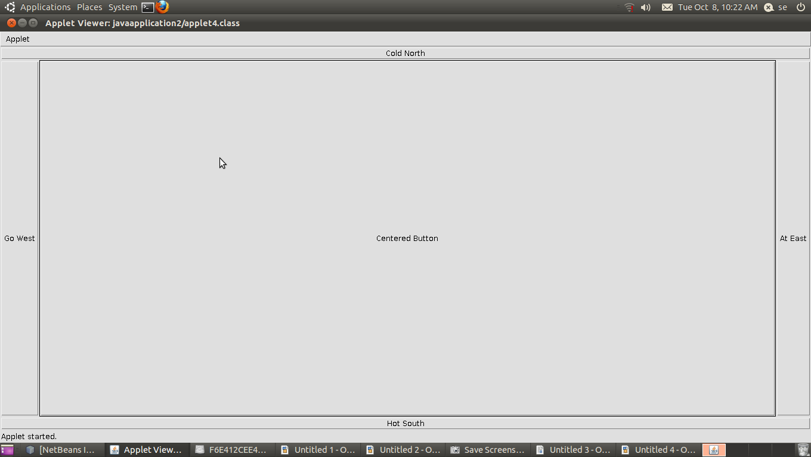
MOUSE LISTENER

CODE:-
import java.awt.*;
import java.applet.*;
import java.awt.event.*;
publicclass applet10 extends Applet implements MouseListener
{
int xpos,ypos;
int rect1xco,rect1yco,rect1width,rect1height;
boolean mouseEntered;
boolean rect1Clicked;
publicvoid init()
{
rect1xco=20;
rect1yco=20;
rect1width=100;
rect1height=50;
addMouseListener(this);
}
publicvoid paint(Graphics g)
{
g.setColor(Color.green);
g.fillRect(rect1xco,rect1yco,rect1width,rect1height);
g.setColor(Color.red);
g.drawString("mouse pointer", xpos, ypos);
if(rect1Clicked)
{
g.drawString("You clicked in the rectangle",20,120);
}
else
{
g.drawString("You clicked outside the rectangle",20,120);
}
if(mouseEntered)
{
g.drawString("Mouse is in the applet area",20,160);
}
else
{
g.drawString("Mouse is outside the applet area",20,160);
}
}
publicvoid mouseClicked(MouseEvent me)
{
xpos=me.getX();
ypos=me.getY();
if((xpos>rect1xco)&&(xpos<rect1xco+rect1width)&&(ypos>rect1yco)&&(ypos<rect1yco+rect1height))
{
rect1Clicked=true;
}
else
{
rect1Clicked=false;
repaint();
}
}
publicvoid mousePressed(MouseEvent me){}
publicvoid mouseReleased(MouseEvent me){}
publicvoid mouseEntered(MouseEvent me)
{
mouseEntered=true;
repaint();
}
publicvoid mouseExited(MouseEvent me)
{
mouseEntered=false;
repaint();
}
}

SHAPES AND COLORS
CODE:-
import java.awt.*;
import java.applet.*;
publicclass applet1 extends Applet
{Font bigFont;
Color redColor;
Color weirdColor;
Color bgColor;
publicvoid init()
{bigFont=new Font("Arial",Font.BOLD,16);
redColor=Color.red;
weirdColor=new Color(60,60,122);
bgColor=Color.blue;
setBackground(bgColor);
}
publicvoid paint(Graphics g)
{g.setFont(bigFont);
g.drawString("SHAPES AND COLOURS",80,20);
g.setColor(redColor);
g.drawRect(100,100,100,100);
g.fillRect(110,110,80,80);
g.setColor(weirdColor);
g.fillArc(120,120,60,60,180,180);
g.setColor(Color.yellow);
g.drawLine(140,140,160,160);
g.setColor(Color.black);} }

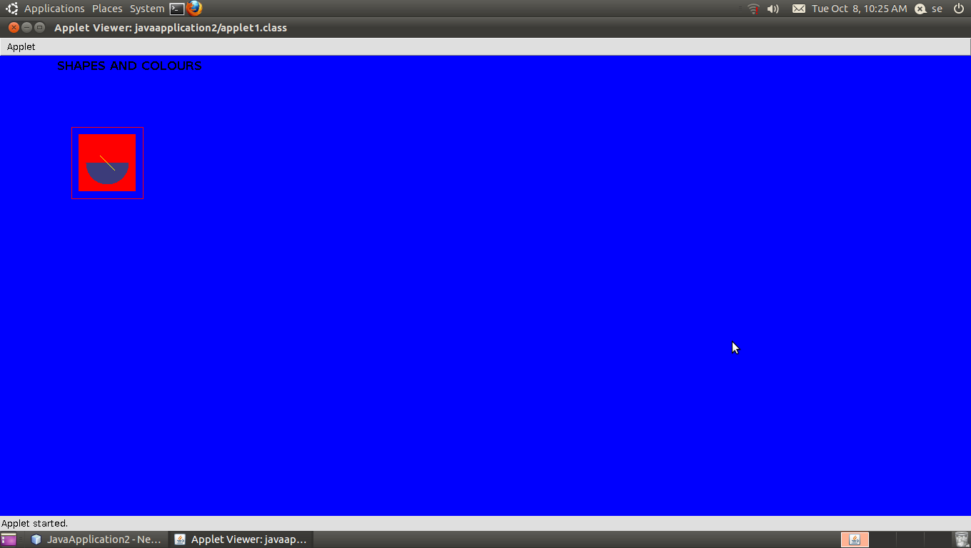

FONTS
CODE:-
import java.awt.*;
import java.applet.*;
publicclass applet7 extends java.applet.Applet
{ Font f1,f2,f3;
publicvoid init()
{ f1=new Font("Times New Roman",Font.BOLD|Font.ITALIC,12);
f2=new Font("Lucida Sans",Font.BOLD,16);
f3=new Font("Georgia",Font.PLAIN,20);
}
publicvoid paint(Graphics g)
{ g.setFont(f1);
g.drawString("Welcome",100,100);
g.setFont(f2);
g.drawString("Welcome",100,200);
g.setFont(f3);
g.drawString("Welcome",100,300);
}

}

ADDITION OF INTEGERS
CODE:-
import java.awt.*;
import java.applet.*;
publicclass applet6 extends Applet
{ Label p;
TextField i;
int n,s;
publicvoid init()
{ p=new Label("Type an integer and press <Enter>");
i=new TextField(10);
add(p);
add(i);
s=0;
}
publicboolean action(Event e,Object o)
{ n=Integer.parseInt(o.toString());
i.setText("");
s=s+n;
showStatus(Integer.toString(s));
returntrue;
}

}
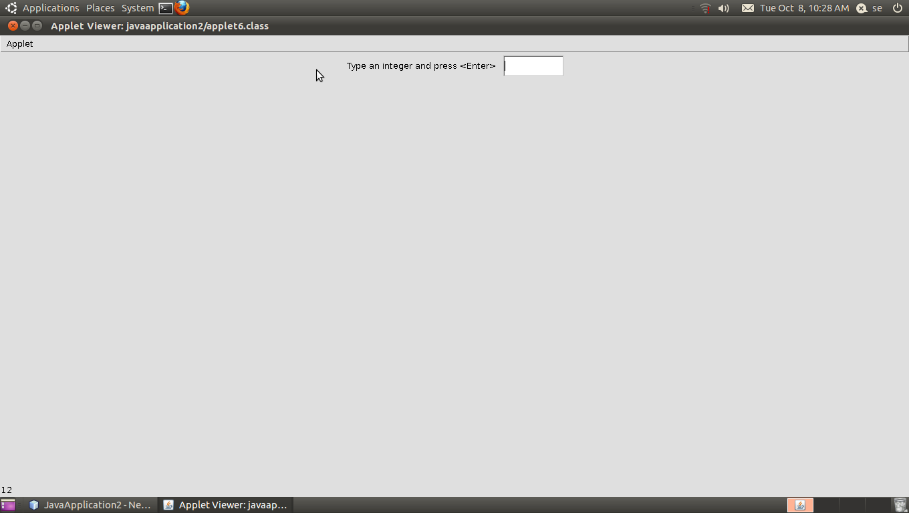

ACTION LISTENER
CODE:-
import java.awt.*;
import java.awt.event.*;
import java.applet.*;
publicclass applet5 extends Applet implements ActionListener
{Button bluebutton;
Button redbutton;
Button greenbutton;
publicvoid init()
{bluebutton=new Button("BLUE");
redbutton=new Button("RED");
greenbutton=new Button("GREEN");
add(bluebutton);
add(redbutton);
add(greenbutton);
bluebutton.addActionListener(this);
redbutton.addActionListener(this);
greenbutton.addActionListener(this);
}
publicvoid actionPerformed(ActionEvent evt)
{if(evt.getSource()==bluebutton)
{setBackground(Color.blue);
}
elseif (evt.getSource()==redbutton)
{setBackground(Color.red);
}
elseif(evt.getSource()==greenbutton)
{setBackground(Color.green);
}
}
}
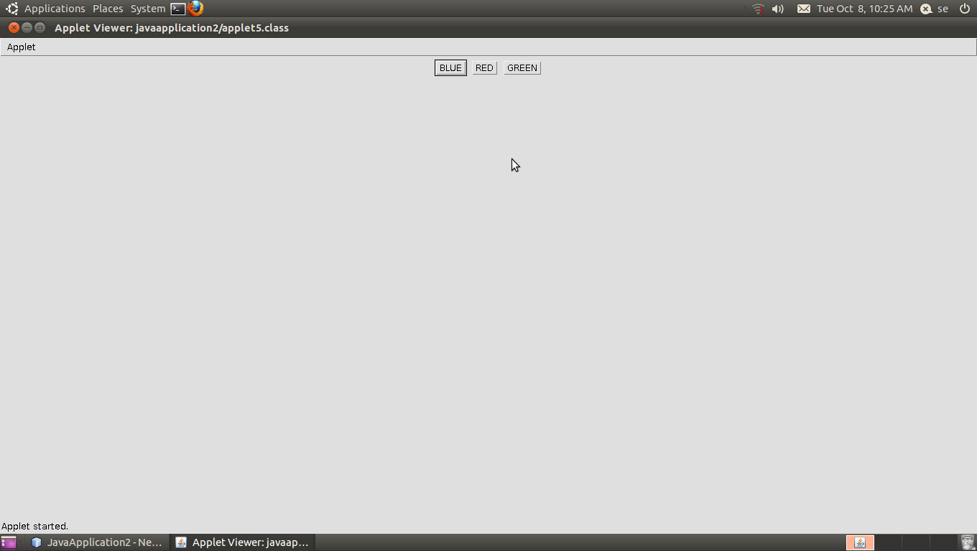
PANEL
CODE:-
import java.awt.*;
import java.applet.*;
publicclass applet9 extends java.applet.Applet
{
Label l1,l2,l3;
Panel p1,p2,p3;
publicvoid init()
{
setLayout(new BorderLayout());
p1=new Panel();
p1.setBackground(Color.blue);
p2=new Panel();
p2.setBackground(Color.green);
p3=new Panel();
p3.setBackground(Color.red);
l1=new Label("THIS IS MY");
p1.add(l1);
l2=new Label("FIRST");
p2.add(l2);
l3=new Label("PANEL PROGRAM");
p3.add(l3);
add(p1,"North");
add(p2,"Center");
add(p3,"South");
}
publicvoid paint(Graphics g)
{
}
}
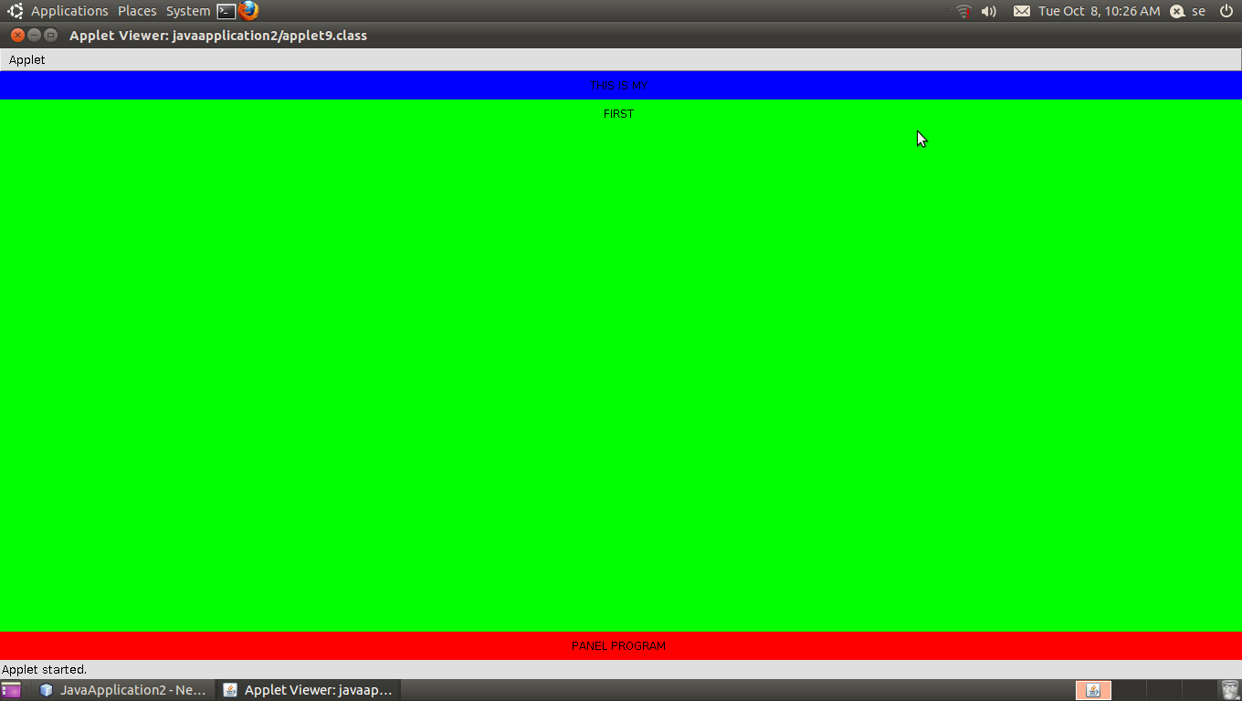

POINT CLASS
CODE:-
import java.awt.*;
publicclass applet8 extends java.applet.Applet
{
Point p1,p2;
publicvoid init()
{
p1=new Point(100,250);
p2=new Point(500,300);
}
publicvoid paint(Graphics g)
{
g.drawLine(p1.x,p1.y,p2.x,p2.y);
}
}

