https://www.w3schools.com/js/js_array_sort.asp

ex 1: create HTML tags using document object
<html>
<head>
<h1> creation of HTML tags</h1>
</head>
<body>
<p>Click the button to create Button tags</p>
<button onclick="createbutton()"> click for button</button>
<button onclick="createpara()"> click for para</button>

<script language="javascript" type="text/javascript">
function createbutton()
{
var btn=document.createElement("BUTTON");
var t=document.createTextNode("click me");
btn.appendChild(t);
document.body.appendChild(btn);
}
function createpara()
{
var para1=document.createElement("P");
var t1=document.createTextNode("this is paragraph");
para1.appendChild(t1);
document.body.appendChild(para1);
}
</script>
</body>
</html>

Output

The Compare Function
The purpose of the compare function is to define an alternative sort order.
The compare function should return a negative, zero, or positive value, depending on the arguments:
Syntax
function(a,b){return a-b}
When the sort() function compares two values, it sends the values to the compare function, and sorts the values according to the returned (negative, zero, positive) value.
Example:
When comparing 40 and 100, the sort() method calls the compare function(40,100).
The function calculates 40-100, and returns -60 (a negative value).
The sort function will sort 40 as a value lower than 100.
Exercise 2:
<html>
<head>
<h1>sorting Program</h1>
</head>
<body>
<p> Click the buttons to sort the array alphabetically or numerically</p>
<button onclick="alphasort()">Sort Alphabetically"</button>
<button onclick="asc_numerical()">ascending numerically"</button>
<button onclick="desc_numerical()">decending numerically"</button>
<p id="p1"></p>
<script language="javascript" type="text/javascript">
var points=[50,20,70,35,19,17,23,100,56,87];
document.getElementById("p1").innerHTML=points;
function alphasort()
{
points.sort();
document.getElementById("p1").innerHTML=points;
}

function asc_numerical()
{
points.sort(function(a,b){return a-b});
document.getElementById("p1").innerHTML=points;
}

function desc_numerical()
{
points.sort(function(a,b){return b-a});
document.getElementById("p1").innerHTML=points;
}

</script>
</body>
</html>

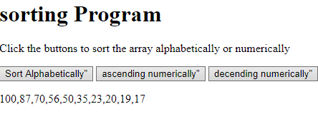
Exercise 3: Factorial
<html>
<head>
<h1>Factorial Program</h1>
</head>
<body>
<p> Click the buttons to find the factorial of the given number</p>
<button onclick="factorial()">find factorial"</button>
<p id="p1"></p>
<p id="p2"></p>
<script language="javascript" type="text/javascript">
var n;
n=prompt("enter the number",0);
function factorial()
{
var fact=1;
if(n<=0)
{
fact=1;
}
else
{
for(i=1;i<=n;i++)
{
fact=fact*i;
}
}
document.getElementById("p1").innerHTML="the factorial for "+n+" is ";
document.getElementById("p2").innerHTML=fact;
}
</script>
</body>
</html>

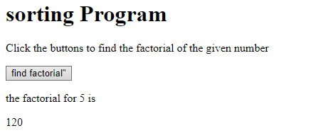
Ex:4 Program to find largest and smallest in the given list
<html>
<head>
<h1>Finding smallest and Largest in an array</h1>
</head>
<body>
<p> Click the buttons to find smallest and largest value</p>
<button onclick="find_max()">Largest element</button>
<button onclick="find_min()">smallest element</button>

<p id="p1"></p>
<p id="p2"></p>
<script language="javascript" type="text/javascript">
var n= prompt("enter the total number");
var points=new Array();
for(i=0;i<n;i++)
{
points[i]=prompt("enter the value");
}
document.getElementById("p1").innerHTML="the given array is "+points;
function find_max()
{
var maxvalue=points[0];
for(var i=0;i<=points.length;i++)
{
if(maxvalue<points[i])
{
maxvalue=points[i];
} //if
} //for
document.getElementById("p2").innerHTML="the maximum value is "+maxvalue;
}

function find_min()
{
var minvalue=points[0];
for(var i=0;i<=points.length;i++)
{
if(minvalue>points[i])
{
minvalue=points[i];
} //if
} //for
document.getElementById("p2").innerHTML="the mainimum value is "+minvalue;
}

</script>
</body>
</html>

Ex: 5 Digital clock
<html>
<head>
<title>Digital Clock</title>
<h1> Digital clock</h1>
</head>
<body>
Current Time : <span id="txt"></span>
<script language="javascript" type="text/javascript">
window.onload=function(){getTime();}
function getTime()
{
var today=new Date();
var h=today.getHours();
var m=today.getMinutes();
var s=today.getSeconds();
if(m<10)
m="0"+m;
if(s<10)
s="0"+s;
document.getElementById('txt').innerHTML=h+" : "+m+" : "+s;
setTimeout(function(){getTime()},500);
}
</script>
</body>
</html>

Output

Digital clock
Current Time : 13 : 42 : 00
Ex:6 create a webpage to display the text “welcome computer science” as a heading and changes its color from black to white and then red at an interval of 1000 milliseconds
<html>
<head>
<h1>Changing the color of text</h1>
</head>
<body bgcolor=pink onload=fontblack();>
<div id="colorchange"><h1>welcome to computer science</h1>
<script language="javascript" type="text/javascript">
function fontblack()
{
document.getElementById("colorchange").style.color="black";
setTimeout("fontred()",1000);
}
function fontred()
{
document.getElementById("colorchange").style.color="red";
setTimeout("fontwhite()",1000);
}

function fontwhite()
{
document.getElementById("colorchange").style.color="white";
setTimeout("fontblack()",1000);
}

</script>

</body>
</html>

Ex:7 Create A Document And A Link To It When The User Moves The Mouse Over The Link It Should Load The Linked Document On Its Own(User Is Not Required To Click On The Link)
PROGRAM:
<html>
<head>
</head>
<body>
<a href="#" onmouseover="linkfunc()"> square function </a>
</body>
<script language="javascript" type="text/javascript">
function linkfunc()
{
window.location="squarefunction.html";
}
</script>
</html>

Output
Ex No : 8
Create a document , which opens a new window without a toolbar, address bar
Program:

Using the window.open method
The syntax of the window.open method is given below:
open (URL, windowName[, windowFeatures])
URL
The URL of the page to open in the new window. This argument could be blank.
windowName
A name to be given to the new window. The name can be used to refer this window again.
windowFeatures
A string that determines the various window features to be included in the popup window (like status bar, address bar etc)
The following code opens a new browser window with standard features.

window.open ("http://jsc.simfatic-solutions.com","mywindow");

With address bar, status bar etc
<html>
<head>
<title>a javascript program for no address bar</title>
</head>
<script type="text/javascript">
function poponload()
{
window1=window.open("","mywindow","location=1,status=1,scrollbars=1,width=100,height=100");
window1=window.open("","mywindow","location=1,status=0,scrollbars=0,toolbar=0,width=100,height=100");
window1.moveTo(0,0)
}
</script>
<body onload="poponload();">
<h1> Javascript popup example</h1>
</body>
</html>

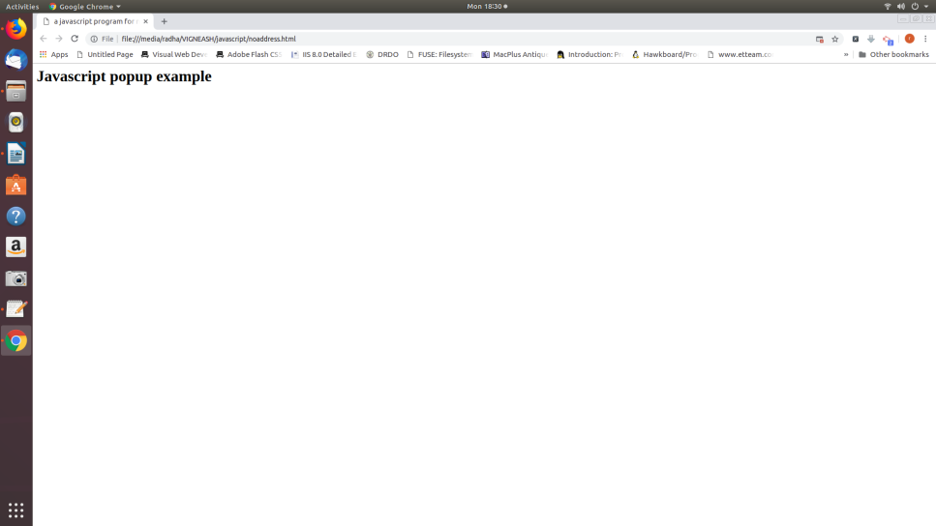

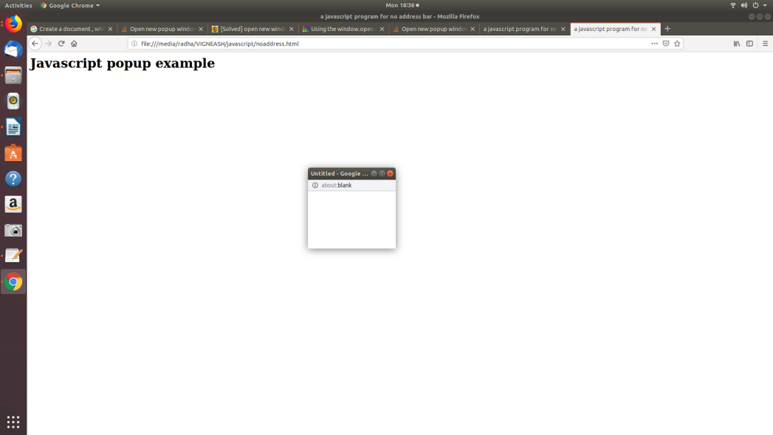

Ex No : 9
CREATE A WEBPAGE FOR GETTING PERSONAL DETIALS USING FORM CONTROLS
Program:
<html>
<head>
<script language="javascript">
function formcheck()
{
var stname=document.forms["regform"]["Name"];
var email=document.forms["regform"]["Email"];
var phone=document.forms["regform"]["mphone"];
var sub=document.forms["regform"]["subject"];
var password= document.forms["regform"]["pass"];
var add1= document.forms["regform"]["address"];
if(stname.value=="")
{
window.alert("Please enter your name");
stname.focus();

}
if(add1.value=="")
{
window.alert("Please enter your address");
add1.focus();
return false;
}
if(phone.value=="")
{
window.alert("Please enter your mobile number");
phone.focus();
return false;
}
if(password.value=="")
{
window.alert("Please enter your password");
password.focus();
return false;
}
<!-- indexOf returns the position of first occurence of a specified string-->
<!-- if search fails it returns a -1 -->
if(email.value.indexOf('@',0)<0)
{
window.alert("Please enter a valid email");
email.focus();
return false;
}

if(email.value.indexOf('.',0)<0)
{
window.alert("Please enter a valid email");
email.focus();
return false;
}

if(sub.selectedIndex<1)
{
window.alert("Please enter your course");
sub.focus();
return false;
}

document.writeln("Your details are : "+"<br>");
document.writeln("Name : "+stname.value+"<br>");
document.writeln("email : "+email.value+"<br>");
document.writeln("mobile no : "+phone.value+"<br>");
document.writeln("Course : "+sub.value+"<br>");
document.writeln("Address : "+add1.value+"<br>");

}

</script>
</head>
<body>
<h1>Registration Form</h1>
<form name="regform" onsubmit="return formcheck()" method="post">
<p> Name: <input type="text" name="Name"></p><br>
<p> Address: <input type="text" name="address"></p><br>
<p> Email: <input type="text" name="Email"></p><br>
<p> Password: <input type="text" name="pass"></p><br>
<p> mobile: <input type="text" name="mphone"></p><br>
<p> select your course
<select type="text" value="" name="subject">
<option> -- </option>
<option> BCA </option>
<option> BSC </option>
<option> B.Com </option>

</select>
</p> <br>
<p><input type="submit" value="send" name="submit">
<input type="reset" value="Reset" name="Reset">
</p>
</form>
</body>
</html>

Output
Ex No : 10
Write a java script program to design a simple calculator using form fields. Have two fields for input and one field for the output. Allow user to be able to do plus, minus, multiply and divide.
<html>
<head>
<script language="javascript">
function add()
{

var a=Number(document.forms["mycal"]["var1"].value);
var b=Number(document.forms["mycal"]["var2"].value);
var c=a+b;
document.mycal.total.value=c;
}

function sub()
{

var a=Number(document.forms["mycal"]["var1"].value);
var b=Number(document.forms["mycal"]["var2"].value);
var c=a-b;
document.mycal.total.value=c;
}

function mul()
{

var a=Number(document.forms["mycal"]["var1"].value);
var b=Number(document.forms["mycal"]["var2"].value);
var c=a*b;
document.mycal.total.value=c;
}

function div()
{

var a=Number(document.forms["mycal"]["var1"].value);
var b=Number(document.forms["mycal"]["var2"].value);
var c=a/b;
document.mycal.total.value=c;
}

</script>
</head>
<body>
<h1> Simple Calculator</h1>
<form name="mycal" >
<pre>
Number1 :<input type="text" name="var1"/>
Number2 :<input type="text" name="var2"/>
Result :<input type="text" name="total"/>
</pre>

<input type="button" value="ADD" onclick="add()">
<input type="button" value="Subtraction" onclick="sub()">
<input type="button" value="multiplication" onclick="mul()">
<input type="button" value="division" onclick="div()">

</form>
</body>
</html>

Output
Ex No : 11
Dynamically creating and animating frame using Javascript.
<html>
<head>
<script language="javascript">
//open a new window
var n=window.open('','f','width=400, height=400');
//dynamically create frames within the above window
n.document.write('<frameset rows="50%,50%" cols="50%,50%">');
n.document.write('<frame name="f1" src="about:blank">');
n.document.write('<frame name="f2" src="about:blank">');
n.document.write('<frame name="f3" src="about:blank">');
n.document.write('<frame name="f4" src="about:blank">');
n.document.write('<frameset>');
// an array of colors to be cycled through the frames created
colors=new Array("red","green","blue","yellow","white");
// an array of frames cycle through (the order)
windows=new Array(n.f1,n.f2,n.f3,n.f4);
// initialize the count for color and frames
var c=0,f=0;
//a variable to hold the current timeout
var timeout=null;

// This function sets the "next" frame in the list to the "next" color
// in the list. We call it once to start the animation, and then it
// arranges to invoke itself every quarter second after that.
function change_one_frame()
{
windows[f].document.write('<body bgcolor='+colors[c]+'>');
windows[f].document.close();
f=(f+1)%4;
c=(c+1)%5;
timeout=setTimeout("change_one_frame()",250);
}
</script>
</head>
<body onload="change_one_frame();">
<form>
<input type="button" value="stop" onClick="if (timeout) clearTimeout(timeout); if(!n.closed) n.close();">

</form>
</body>
</html>

Output

Ex No : 12
An Animation Using the onLoad() Event Handler using Javascript

<html>
<head>
<title>Javascript animation</title>
<script type="text/javascript" language="javascript">
var imgobj=null;
var animate;
function init()
{
imgobj=document.getElementById("mypic");
imgobj.style.position='relative';
imgobj.style.left='0px';
}
function moveRight()
{
imgobj.style.left=parseInt(imgobj.style.left) + 10 + 'px';
}
function stop()
{
clearTimeout(animate);
imgobj.style.left='0px';
}
window.onload=init;
</script>
</head>
<body>
<form>
<img id="mypic" src="image1.gif">
<p> click button below to move the image to right</p>
<input type="button" value="click me" onclick="moveRight();"/>
<input type="button" value="stop" onclick="stop();"/>
</form>

</body>

</html>
Output

Ex No : 13
Implementing a Toggle Button with Image Replacement using Javascript

<html>
<head>
<h1> changing the image</h1>
</head>
<body>
<script language="javascript">
function changeImage()
{
var img=document.getElementById("image1");
if(img.src.match("image1"))
{
img.src="image2.gif";
}
else
{
img.src="image1.gif";
}
}
</script>
</body>
<img src="image1.gif" id="image1" width=100 height="100">
<input type="button" onclick="changeImage()" value="change">
<p> click the "change" button </p>

</html>

Output
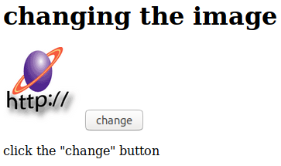
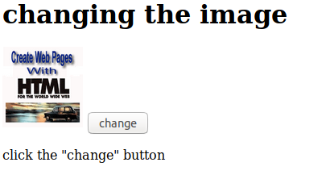

Ex No : 14
An HTML Form Containing all Form Elements using Javascript

<html>
<head>
<script language="javascript">
function formcheck()
{
var stname=document.forms["regform"]["Name"];

var email=document.forms["regform"]["Email"];
var phone=document.forms["regform"]["mphone"];
var sub=document.forms["regform"]["subject"];
var password= document.forms["regform"]["pass"];
var add1= document.forms["regform"]["address"];
if(stname.value=="")
{
window.alert("Please enter your name");
stname.focus();

}
if(add1.value=="")
{
window.alert("Please enter your address");
add1.focus();
return false;
}
if(phone.value=="")
{
window.alert("Please enter your mobile number");
phone.focus();
return false;
}
if(password.value=="")
{
window.alert("Please enter your password");
password.focus();
return false;
}
<!-- indexOf returns the position of first occurence of a specified string-->
<!-- if search fails it returns a -1 -->
if(email.value.indexOf('@',0)<0)
{
window.alert("Please enter a valid email");
email.focus();
return false;
}

if(email.value.indexOf('.',0)<0)
{
window.alert("Please enter a valid email");
email.focus();
return false;
}

if(sub.selectedIndex<1)
{
window.alert("Please enter your course");
sub.focus();
return false;
}

if(document.getElementById("r1").checked)
{
var x=document.getElementById("r1").value;
}
else
{
var x=document.getElementById("r2").value;
}

if(document.getElementById("c1").checked==true)
{
var y=document.getElementById("c1").value;
}
else
{
var y=" ";
}
if(document.getElementById("c2").checked==true)
{
var y1=document.getElementById("c2").value;
}
else
{
var y1=" ";
}

if(document.getElementById("c3").checked==true)
{
var y2=document.getElementById("c3").value;
}
else
{
var y2=" ";
}
var yy=y+y1+y2;
document.writeln("Your details are : "+"<br>");
document.writeln("Name : "+stname.value+"<br>");
document.writeln("sex is : "+x + "<br>");
document.writeln("email : "+email.value+"<br>");
document.writeln("mobile no : "+phone.value+"<br>");
document.writeln("Course : "+sub.value+"<br>");
document.writeln("Address : "+add1.value+"<br>");
document.writeln("your hobies are : " +yy);

}

</script>
</head>
<body>
<h1>Registration Form</h1>
<form name="regform" onsubmit="return formcheck()" method="post">
<p> Name: <input type="text" name="Name"></p><br>
<p> SEX : <input type="radio" id="r1" name="sex" value="male">Male
<input type="radio" id="r2" name="sex" value="female">Female</p><br>
<p> Address: <input type="text" name="address"></p><br>
<p> Email: <input type="text" name="Email"></p><br>
<p> Password: <input type="text" name="pass"></p><br>
<p> mobile: <input type="text" name="mphone"></p><br>
<p> select your course
<select type="text" value="" name="subject">
<option> -- </option>
<option> BCA </option>
<option> BSC </option>
<option> B.Com </option>

</select>
</p> <br>
<input type="checkbox" name="hobby" id="c1" value="cricket">cricket
<input type="checkbox" name="hobby" id="c2" value="reading">reading
<input type="checkbox" name="hobby" id="c3" value="TV">TV
<p><input type="submit" value="send" name="submit">
<input type="reset" value="Reset" name="Reset">
</p>
</form>
</body>
</html>

Output

Ex No : 15

Estimating Your Taxes with JavaScript
<html>
<head>
<script language="javascript">
function formcheck()
{
var tsalary=document.forms["itform"]["tsalary"].value;
var hloan=document.forms["itform"]["hloan"].value;
var ptax=document.forms["itform"]["ptax"].value;
var sav_amount=document.forms["itform"]["sav_amount"].value;
var a = tsalary-hloan-ptax-sav_amount;
var caltax=a*.20;
var itax=document.forms["itform"]["itax"].value;
var tobepaid=caltax-itax;

document.writeln("Your details are : "+"<br>");
document.writeln("total salary : "+tsalary+"<br>");
document.writeln("housing loan : "+hloan+"<br>");
document.writeln("professional tax : "+ptax+"<br>");
document.writeln("savings amount : "+sav_amount+"<br>");
document.writeln("you have to pay : "+caltax+"<br>");
document.writeln("income tax so far paid : "+itax+"<br>");
document.writeln("the remaining amount to be paid as income tax:"+tobepaid);

}

</script>
</head>
<body>
<h1>Income Tax calculation</h1>
<form name="itform" onsubmit="return formcheck()" method="post">
<p> Name: <input type="text" name="Name"></p><br>
<p> total salary: <input type="text" name="tsalary"></p><br>
<p> less housing loan interest (upto 2,00,000 lakhs only <input type="text" name="hloan"></p><br>
<p> less professional tax: <input type="text" name="ptax"></p><br>
<p> less savings upto (1,50,000 only): <input type="text" name="sav_amount"></p><br>
<p> IT so far deducted (add cess also): <input type="text" name="itax"></p><br>
<br>
<p><input type="submit" value="send" name="submit">
<input type="reset" value="Reset" name="Reset">
</p>
</form>
</body>
</html>

