Inheritance
Types of inheritance
- Single inheritance
- Multiple inheritance
- Multilevel inheritance
- Hierarchical inheritance
- Hybrid inheritance
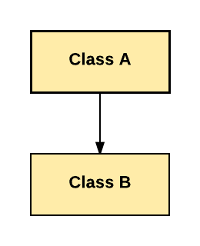
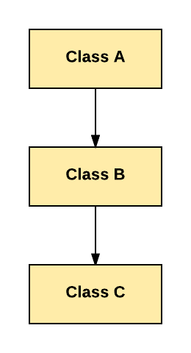
single inheritance

Multiple inheritance
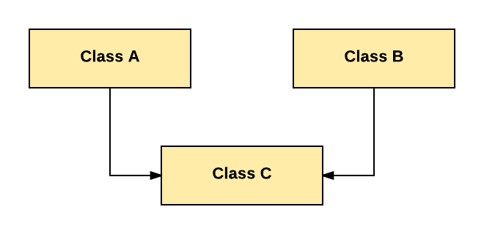

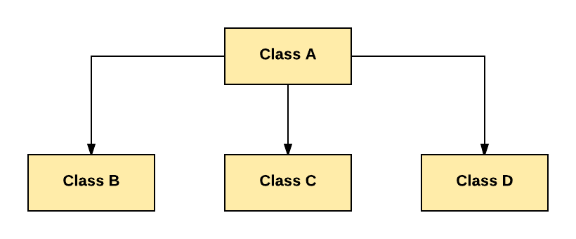
Hierarchical inheritance

Multilevel inheritance
Hybrid inheritance
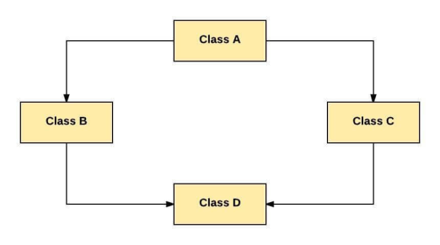
- Java inheritance syntax
class subClass extends superClass
{
//methods and fields
}
- Usage of java super Keyword
- super can be used to refer immediate parent class instance variable.
- super can be used to invoke immediate parent class method.
- super() can be used to invoke immediate parent class constructor

Simple Inheritance example
class Animal
{
void eat()
{
System.out.println("eating");
}
}
class Dog extends Animal
{
void bark()
{
System.out.println("barking");
}
}
public class simpleinherit {
public static void main(String[] args) {
{
Dog obj=new Dog();
obj.eat();
obj.bark();
}
}
}

Another example
class Box
{
double width;
double height;
double depth;

//constructor
Box(Box obj)
{
width=obj.width;
height=obj.height;
depth=obj.depth;
}
//constructor
Box(double w, double h,double d)
{
width=w;
height=h;
depth=d;
}
//constructor
Box()
{
width=-1;
height=-1;
depth=-1;
}

//constructor
Box(double len)
{
width=len;
height=len;
depth=len;

}
double volume()
{
return(width*height*depth);
}
}
class Boxweight extends Box
{
double weight;
Boxweight(double w,doubleh,doubled,double m)
{
width=w;
height=h;
depth=d;
weight=m;
}
}

class boxweightdemo
{
public static void main(String args[])
{
Boxweight obj1=new Boxweight(10,20,30,40);
Boxweight obj2=new Boxweight(1,2,3,4);
double vol1,vol2;
vol1=obj1.volume();
vol2=obj2.volume();
System.out.println("volume of box1 is = "+vol1);
System.out.println("weight of box1 is = "+obj1.weight);

System.out.println("volume of box2 is = "+vol2);
System.out.println("weight of box2 is = "+obj2.weight);
}
}

output
E:\javaprgs>javac boxweightdemo.java

E:\javaprgs>java boxweightdemo
volume of box1 is = 6000.0
weight of box1 is = 40.0
volume of box2 is = 6.0
weight of box2 is = 4.0
Use of super keyword with variables
class A
{
String x="welcome";
}
class B extends A
{
String x="java";
void display()
{
System.out.println(x);
System.out.println(super.x);
}
}
public class superkeyword {
public static void main(String[] args) {
B obj=new B();
obj.display();
}
}

Use of super keyword with methods
class A
{
String x="welcome";
void display()
{
System.out.println(x);
}}
class B extends A
{
String x="java";
void display()
{
super.display();
System.out.println(x);
}}
public class superkeyword {
public static void main(String[] args) {
B obj=new B();
obj.display();
}
}

Use of super keyword with constructor
class Account
{
intaccnum,balance;
Account(intaccnum,int balance)
{
this.accnum=accnum;
this.balance=balance;
}
void credit(int amount)
{
balance=balance+amount;
}
void debit(int amount)
{
balance=balance-amount;
}
void displaybalance()
{
System.out.println("balance = "+balance);
}
}
class SBAccount extends Account
{
double rate;
SBAccount(intaccnum,intbalance,double rate)
{
super(accnum,balance);
this.rate=rate;
}
void displayrate()
{
System.out.println("Interest rate= "+rate);
}
}
public class construct_inherit {
public static void main(String[] args) {
SBAccount obj1=new SBAccount(1001,5000,6.5);
obj1.credit(2000);
obj1.debit(100);
obj1.displaybalance();
obj1.displayrate();
}
}

class College
{
String collegename,principalname;
College(String cn,Stringpn)
{
this.collegename=cn;
this.principalname=pn;
}
voiddisplaycollegedetails()
{
System.out.println("Collegename : "+collegename);
System.out.println("Principal name : "+principalname);
}
}
class Department extends College
{
String deptname,hodname;
Department(String cn,Stringpn, String dept,Stringhod)
{
super(cn,pn);
this.deptname=dept;
this.hodname=hod;
}
voiddisplaydeptdetails()
{
System.out.println("department : "+deptname);
System.out.println("HOD name : "+hodname);
}

}
publicclasscollegedemo {

publicstaticvoid main(String[] args) {
Department obj=new Department("SDNB","Varalakshmi","CSC","Sumathi");
obj.displaycollegedetails();
obj.displaydeptdetails();
Department obj1=new Department("SDNB","Varalakshmi","Maths","Vijaya");
obj1.displaycollegedetails();
obj1.displaydeptdetails();

}

}

Another example of using super with constructors
class Box
{
double width;
double height;
double depth;

//constructor
Box(Box obj)
{
width=obj.width;
height=obj.height;
depth=obj.depth;
}
//constructor
Box(double w, double h,double d)
{
width=w;
height=h;
depth=d;
}
//constructor
Box()
{
width=-1;
height=-1;
depth=-1;
}

//constructor
Box(double len)
{
width=len;
height=len;
depth=len;

}
double volume()
{
return(width*height*depth);
}
}
class Boxweight extends Box
{
double weight;
Boxweight(double w,doubleh,doubled,double m)
{
super(w,h,d);
weight=m;
}
}

class boxweightdemo1
{
public static void main(String args[])
{
Boxweight obj1=new Boxweight(10,20,30,40);
Boxweight obj2=new Boxweight(1,2,3,4);
double vol1,vol2;
vol1=obj1.volume();
vol2=obj2.volume();
System.out.println("volume of box1 is = "+vol1);
System.out.println("weight of box1 is = "+obj1.weight);

System.out.println("volume of box2 is = "+vol2);
System.out.println("weight of box2 is = "+obj2.weight);

}
}

Another example
class Box
{
double width;
double height;
double depth;

//constructor
Box(Box obj)
{
width=obj.width;
height=obj.height;
depth=obj.depth;
}
//constructor
Box(double w, double h,double d)
{
width=w;
height=h;
depth=d;
}
//constructor
Box()
{
width=-1;
height=-1;
depth=-1;
}

//constructor
Box(double len)
{
width=len;
height=len;
depth=len;

}
double volume()
{
return(width*height*depth);
}
}
class Boxweight extends Box
{
double weight;
Boxweight(double w,doubleh,doubled,double m)
{
super(w,h,d);
weight=m;
}
Boxweight(Boxweightobj)
{
super(obj);
weight=obj.weight;
}
Boxweight()
{
super();
weight=-1;
}
Boxweight(double len)
{
super(len);
weight=len;
}
}

class boxweightdemo1
{
public static void main(String args[])
{
Boxweight obj1=new Boxweight(10,20,30,40);
Boxweight obj2=new Boxweight(1,2,3,4);
Boxweight obj3=new Boxweight();
Boxweight obj4=new Boxweight(5.2);
Boxweight obj5=new Boxweight(obj2);
double vol1,vol2,vol3,vol4,vol5;
vol1=obj1.volume();
vol2=obj2.volume();
vol3=obj3.volume();
vol4=obj4.volume();
vol5=obj5.volume();
System.out.println("calling construtor with four variables");
System.out.println("volume of box1 is = "+vol1);
System.out.println("weight of box1 is = "+obj1.weight);
System.out.println("calling construtor with four variables");
System.out.println("volume of box2 is = "+vol2);
System.out.println("weight of box2 is = "+obj2.weight);
System.out.println("calling construtor with -1 value");
System.out.println("volume of box3 is = "+vol3);
System.out.println("weight of box3 is = "+obj3.weight);

System.out.println("calling construtor with one value");
System.out.println("volume of box4 is = "+vol4);
System.out.println("weight of box4 is = "+obj4.weight);

System.out.println("calling construtor with object value");
System.out.println("volume of box5 is = "+vol5);
System.out.println("weight of box5 is = "+obj5.weight);

}
}
Output
E:\javaprgs>javac boxweightdemo1.java

E:\javaprgs>java boxweightdemo1
calling construtor with four variables
volume of box1 is = 6000.0
weight of box1 is = 40.0
calling construtor with four variables
volume of box2 is = 6.0
weight of box2 is = 4.0
calling construtor with -1 value
volume of box3 is = -1.0
weight of box3 is = -1.0
calling construtor with one value
volume of box4 is = 140.60800000000003
weight of box4 is = 5.2
calling construtor with object value
volume of box5 is = 6.0
weight of box5 is = 4.0

Creating multilevel inheritance
class Box
{
double width;
double height;
double depth;

//constructor
Box(Box obj)
{
width=obj.width;
height=obj.height;
depth=obj.depth;
}
//constructor
Box(double w, double h,double d)
{
width=w;
height=h;
depth=d;
}
//constructor
Box()
{
width=-1;
height=-1;
depth=-1;
}

//constructor
Box(double len)
{
width=len;
height=len;
depth=len;

}
double volume()
{
return(width*height*depth);
}
}
class Boxweight extends Box
{
double weight;
Boxweight(double w,doubleh,doubled,double m)
{
super(w,h,d);
weight=m;
}
Boxweight(Boxweightobj)
{
super(obj);
weight=obj.weight;
}
Boxweight()
{
super();
weight=-1;
}
Boxweight(double len)
{
super(len);
weight=len;
}
}

class shipment extends Boxweight
{
double cost;
shipment(double w,doubleh,doubled,doublem,double c)
{
super(w,h,d,m);
cost=c;
}
shipment(shipment obj)
{
super(obj);
cost=obj.cost;
}
shipment()
{
super();
cost=-1;
}
shipment(double len)
{
super(len);
cost=len;
}
}
class multilevelinherit
{
public static void main(String args[])
{
shipment obj1=new shipment(10,20,30,40,50);
shipment obj2=new shipment(1,2,3,4,5);
shipment obj3=new shipment();
shipment obj4=new shipment(5.2);
shipment obj5=new shipment(obj2);
double vol1,vol2,vol3,vol4,vol5;
vol1=obj1.volume();
vol2=obj2.volume();
vol3=obj3.volume();
vol4=obj4.volume();
vol5=obj5.volume();
System.out.println("calling construtor with four variables");
System.out.println("volume of box1 is = "+vol1);
System.out.println("weight of box1 is = "+obj1.weight);
System.out.println("cost of box1 is = "+obj1.cost);

System.out.println("calling construtor with four variables");
System.out.println("volume of box2 is = "+vol2);
System.out.println("weight of box2 is = "+obj2.weight);
System.out.println("cost of box2 is = "+obj2.cost);

System.out.println("calling construtor with -1 value");
System.out.println("volume of box3 is = "+vol3);
System.out.println("cost of box3 is = "+obj3.cost);

System.out.println("weight of box3 is = "+obj3.weight);

System.out.println("calling construtor with one value");
System.out.println("volume of box4 is = "+vol4);
System.out.println("weight of box4 is = "+obj4.weight);
System.out.println("cost of box4 is = "+obj4.cost);

System.out.println("calling construtor with object value");
System.out.println("volume of box5 is = "+vol5);
System.out.println("weight of box5 is = "+obj5.weight);
System.out.println("cost of box5 is = "+obj5.cost);

}
}

Output
E:\javaprgs>javac multilevelinherit.java

E:\javaprgs>java multilevelinherit
calling construtor with four variables
volume of box1 is = 6000.0
weight of box1 is = 40.0
cost of box1 is = 50.0
calling construtor with four variables
volume of box2 is = 6.0
weight of box2 is = 4.0
cost of box2 is = 5.0
calling construtor with -1 value
volume of box3 is = -1.0
cost of box3 is = -1.0
weight of box3 is = -1.0
calling construtor with one value
volume of box4 is = 140.60800000000003
weight of box4 is = 5.2
cost of box4 is = 5.2
calling construtor with object value
volume of box5 is = 6.0
weight of box5 is = 4.0
cost of box5 is = 5.0

Another example for multilevel inheritance
import java.lang.*;
import java.io.*;
class Account
{
String cust_name;
intacc_no;
Account(String a,int b)
{
cust_name=a;
acc_no=b;
}
void display()
{
System.out.println("Customer name: "+cust_name);
System.out.println("Account no : "+acc_no);
}

} // end -class Account
class Saving_Acc extends Account
{
intmin_bal, saving_bal;
Saving_Acc(String a, int b, intc,int d)
{
super(a,b);
min_bal=c;
saving_bal=d;
}
void display()
{
super.display();
System.out.println("MInimum Balance: "+min_bal);
System.out.println("Saving Balance : "+saving_bal);

}
} // end-class Saving_Acc
class Acctdetails extends Saving_Acc
{
int deposits, withdrawals;
Acctdetails(String a, int b, intc,int d, int e, int f)
{
super(a,b,c,d);
deposits=e;
withdrawals=f;
}
void display()
{
super.display();
System.out.println("Deposit: "+ deposits);
System.out.println("withdrawals : "+withdrawals);
}
} //end - class Acctdetails

class multilevel
{
public static void main(String args[])
{
Acctdetailsobj=new Acctdetails("xxx",666,1000,5000,500,9000);
obj.display();
}
}

Output
D:\javaprgs>javac multilevel.java

D:\javaprgs>java multilevel
Customer name: xxx
Account no : 666
MInimum Balance: 1000
Saving Balance : 5000
Deposit: 500
withdrawals : 9000

Another example for multilevel inheritance
//multilevel inheritance
importjava.io.*;
classstudentdetail
{
introllno;
String stname, brname,year;
studentdetail(intr, String sn,Stringbn,Stringy)
{
rollno=r;
stname=sn;
brname=bn;
year=y;
}
voiddisplay()
{
System.out.println(" \n\t\t\t The student details");
System.out.println("student rollno : "+rollno);
System.out.println("student name : "+stname);
System.out.println("student branch : "+brname);
System.out.println("student year : "+year);
}
}

class mark extendsstudentdetail
{
String category;
intmark1,mark2,mark3;
mark(intr,Stringsn,Stringbn,Stringy,Stringcat,intm1,intm2,intm3)
{
super(r,sn,bn,y);
category=cat;
mark1=m1;
mark2=m2;
mark3=m3;
}
voiddisplay()
{
super.display();
System.out.println("student category : "+category);
System.out.println("mark1 : "+mark1);
System.out.println("mark2 : "+mark2);
System.out.println("mark3 : "+mark3);
}
}
class report extends mark
{
doubletotal,avg;
String grade;
report(intr,Stringsn,Stringbn,Stringy,Stringcat,intm1,intm2,intm3)
{
super(r,sn,bn,y,cat,m1,m2,m3);
}

voidtot()
{
total=mark1+mark2+mark3;
avg=total/3.0;
if ((mark1>=40) && (mark2>=40) && (mark3>=40))
{
if(avg>=80)
grade="Distinction";
elseif((avg>=60) &&(avg<80))
grade="First class";
else
grade="Second class";
}
else
grade="Fail";

}
voiddisplay()
{
tot();
super.display();
System.out.println("total = "+total);
System.out.println("average = "+avg);
System.out.println("Grade = "+grade);
}
}
publicclass multilevel1 {
publicstaticvoid main(String[] args) throwsIOException
{
intid,m1,m2,m3;
String name,br,cat,yr;
charch;
DataInputStreamdin=newDataInputStream(System.in);
do
{
System.out.println("Enter student id");
id=Integer.parseInt(din.readLine());
System.out.println("Enter student name");
name=din.readLine();
System.out.println("Enter branch name");
br=din.readLine();
System.out.println("Enter category");
cat=din.readLine();
System.out.println("Enter year");
yr=din.readLine();
System.out.println("Enter mark1");
m1=Integer.parseInt(din.readLine());
System.out.println("Enter mark2");
m2=Integer.parseInt(din.readLine());
System.out.println("Enter mark3");
m3=Integer.parseInt(din.readLine());
report obj=new report(id,name,br,yr,cat,m1,m2,m3);
obj.display();
System.out.println("want to continue? (Y/N)");
ch=(din.readLine()).charAt(0);
} while (ch=='y' || ch=='Y');
}
}
Output
Enter student id
100
Enter student name
anitha
Enter branch name
csc
Enter category
day
Enter year
first
Enter mark1
90
Enter mark2
80
Enter mark3
90

The student details
student rollno : 100
student name :anitha
student branch :csc
student year : first
student category : day
mark1 : 90
mark2 : 80
mark3 : 90
total = 260.0
average = 86.66666666666667
Grade = Distinction
want to continue? (Y/N)

Constructor order execution
class A
{
A()
{
System.out.println("this is A's constructor");
}
}

class B extends A
{
B()
{
System.out.println("this is B's constructor");
}
}

class C extends B
{
C()
{
System.out.println("this is C's constructor");
}
}

class constructororder
{
public static void main(String args[])
{
C obj=new C();
}
}
output
E:\javaprgs>javac constructororder.java

E:\javaprgs>java constructororder
this is A's constructor
this is B's constructor
this is C's constructor
Method overriding in constructor classes
class A
{
inti,j;
A(inta,int b)
{
i=a;
j=b;
}
void show()
{
System.out.println("this is from class A ");
System.out.println("i = "+i+" j = "+j);
}
}

class B extends A
{
int k;
B(inta,int b, int c)
{
super(a,b);
k=c;
}
void show()
{
System.out.println("this is from class B ");
System.out.println("k = "+k);
}
}

class methodoverriding
{
public static void main(String args[])
{
B obj=new B(1,2,3);
obj.show();
}
}
Output
this is from class B
k = 3
To access the base class overriding methods use super
class A
{
inti,j;
A(inta,int b)
{
i=a;
j=b;
}
void show()
{
System.out.println("this is from class A ");
System.out.println("i = "+i+" j = "+j);
}
}

class B extends A
{
int k;
B(inta,int b, int c)
{
super(a,b);
k=c;
}
void show()
{
super.show(); // this calls the parent class method
System.out.println("this is from class B ");
System.out.println("k = "+k);
}
}

class methodoverriding
{
public static void main(String args[])
{
B obj=new B(1,2,3);
obj.show();
}
}
Output
E:\javaprgs>javac methodoverriding.java

E:\javaprgs>java methodoverriding
this is from class A
i = 1 j = 2
this is from class B
k = 3
Superclass variable can reference a subclass object
//superclass variable referenc a subclass object
class A
{
inti,j;
A(inta,int b)
{
i=a;
j=b;
}
void show()
{
System.out.println("i = "+i+" j= "+j);
}
}
class B extends A
{
int k;
B(inta,intb,int c)
{
super(a,b);
k=c;
}
void show()
{
System.out.println("k = "+k);
}
}

class C extends B
{
int z;
C(inta,intb,intc,int d)
{
super(a,b,c);
z=d;
}
void show()
{
System.out.println("z = "+z);
}

}

class refdemo
{
public static void main(String args[])
{
B subobj=new B(1,2,3);
C subobj2=new C(1,2,3,4);
A superobj;
subobj.show();
superobj=subobj;
superobj.show();
superobj=subobj2;
superobj.show();
}
}
Output
E:\javaprgs>javac refdemo.java

E:\javaprgs>java refdemo
k = 3
k = 3
z = 4
Dynamic method dispatch
Dynamic method dispatch is the mechanism by which a call to an overridden method is resolved at run time, rather than at compile time and this is how java implements run-time polymorphism.
A super class reference variable can refer to a subclass object
class A
{
void callme()
{
System.out.println("Inside A");
}
}
class B extends A
{
void callme() //overriding
{
System.out.println("Inside B");
}
}
class C extends B
{
void callme()
{
System.out.println("Inside C");
}
}

class dispatch
{
public static void main(String args[])
{
A a=new A();
B b=new B();
C c=new C();
A r; //obtain a reference of type A
r=a; // r referes to an A object
r.callme();
r=b;
r.callme();
r=c;
r.callme();
}
}
Output
E:\javaprgs>java dispatch
Inside A
Inside B
Inside C
Overridden methods achieve run-time polymorphism
// using run-time polymorphism
class Figure
{
double dim1;
double dim2;
Figure(double a, double b)
{
dim1=a;
dim2=b;
}
double area()
{
System.out.println("area of figure");
return 0;
}
}
class Rectangle extends Figure
{
Rectangle(double a, double b)
{
super(a,b);
}
//override area in superclass
double area()
{
System.out.println("area of rectangle");
return dim1*dim2;
}
}

class Triangle extends Figure
{
Triangle(double a,double b)
{
super(a,b);
}
double area()
{
System.out.println("area of triangle");
return dim1*dim2/2;
}
}
class Findarea
{
public static void main(String args[])
{
Figure f=new Figure(10,10);
Rectangle r=new Rectangle(20,20);
Triangle t=new Triangle(30,30);
Figure figref;
figref=r;
System.out.println("Area of rectangle "+figref.area());

figref=t;
System.out.println("Area of triangle "+figref.area());

figref=f;
System.out.println("Area of figure "+figref.area());

}
}
Output
E:\javaprgs>javac Findarea.java

E:\javaprgs>java Findarea
area of rectangle
Area of rectangle 400.0
area of triangle
Area of triangle 450.0
area of figure
Area of figure 0.0

Abstraction is a process of hiding the implementation details and showing only functionality to the user.
A class for which we cannot create objects is called abstract class. An abstract class is to be extended and then instantiated.
Another way, it shows only important things to the user and hides the internal details for example sending sms, you just type the text and send the message. You don't know the internal processing about the message delivery.

Example abstract class
- abstract class A{}

abstract method
A method that is declared as abstract and does not have implementation is known as abstract method.

Example abstract method
abstract void printStatus();//no body and abstract
The following will give error.
abstractclass A
{

}

publicclassabstractdemo {

publicstaticvoid main(String[] args) {
A obj=newobj();
}

}

Exception in thread "main" java.lang.Error: Unresolved compilation problem:
Cannot instantiate the type A

at Construct_inherit.abstractdemo.main(abstractdemo.java:10)

abstractclass A
{

}
class B extends A
{
Void display()
{
System.out.println("welcome");
}
}
public class abstractdemo {

public static void main(String[] args) {
B obj=new B();
obj.display();
}

}

Use of abstract method
abstract class A1
{
abstract void show1();
}
Class B1 extends A1
{

void show1()//abstract method-coding is given here
{
System.out.println("this is abstract method");
}
}
publicclass abstractdemo2 {

public static void main(String[] args) {
B1obj=newB1();
obj.show1();
}

}

Abstract class, abstract method with ordinary method
abstractclass A1
{
Abstract void show1();
void show2()
{
System.out.println("welcome");
}
}
class B1 extends A1
{

void show1()
{
System.out.println("this is abstract method");
}
}
publicclass abstractdemo3 {

publicstaticvoid main(String[] args) {
B1 obj=new B1();
obj.show1();
obj.show2();
}
}

An abstract method should be defined inside an abstract class only. For eg
class A
{
abstract void show();
}

The above declaration will produce an error.
Example :Abstract class inherited in more than one class
abstract clas scompcentre
{
abstract int numcomp();
}

class centre1 extends compcentre
{
int numcomp()
{
return 45;
}
}
class centre2 extends compcentre
{
int numcomp()
{
return 11;
}
}
publicclass abstractdemo4 {

publicstaticvoid main(String[] args) {
centre1 obj1=new centre1();
centre2 obj2=new centre2();
System.out.println("the number of computers in centre1 is= "+obj1.numcomp());
System.out.println("the number of computers in centre2 is= "+obj2.numcomp());
}
}

Another example
abstractclass Shape
{
abstractvoiddraw();
}

class Rectangle extends Shape
{
voiddraw()
{
System.out.println("drawing rectangle");
}
}
class circle extends Shape
{
voiddraw()
{
System.out.println("drawing circle");
}
}
publicclass abstractdemo6 {

publicstaticvoid main(String[] args) {
circle s=newcircle();
Rectangle r=newRectangle();
s.draw();
r.draw();

}
}

Abstract class with constructor, ordinary method, abstract method
abstractclass Bike
{
Bike()
{
System.out.println("bike is created");
}
abstractvoidrun();
voidchangegear()
{
System.out.println("gear changed");
}

}
classHondaextends Bike
{
voidrun()
{
System.out.println("bike is running");
}
}

publicclass abstractdemo5 {

publicstaticvoid main(String[] args) {
Hondaobj=newHonda();
obj.run();
obj.changegear();

}

}

Access specifiers / modifiers
Access modifiers are those which are applied before data members or methods of a class. These are used to where to access and where not to access the data members or methods. In Java programming these are classified into four types:
- Private
- Default (not a keyword)
- Protected
- Public

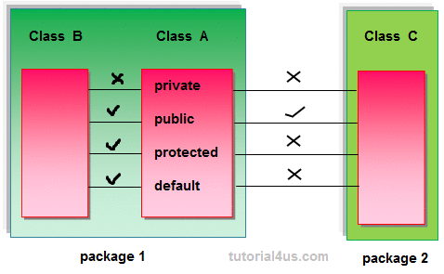
Protected members of the class are accessible within the same class and another class of same package and also accessible in inherited class of another package.

Rules for access modifiers:
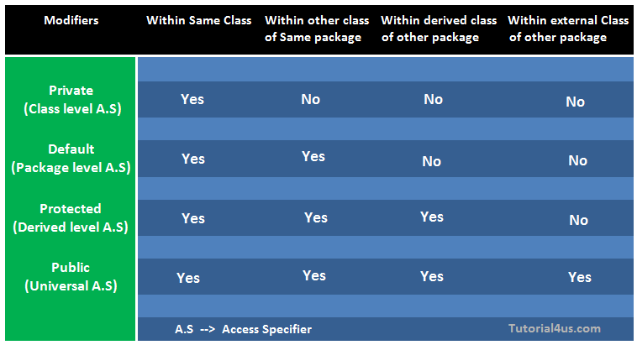
private: Private members of class in not accessible anywhere in program these are only accessible within the class. Private are also called class level access modifiers

// program for private access
class hello
{
private int a=10;
private void show()
{
System.out.println("hello java");
}
}

public class privatedemo
{
public static void main(String args[])
{
hello obj=new hello();
System.out.println(obj.a);
obj.show();
}
}
Output

E:\javaprgs>javac privatedemo.java
privatedemo.java:16: a has private access in hello
System.out.println(obj.a);
^
privatedemo.java:17: show() has private access in hello
obj.show();
^
2 errors.

public: Public members of any class are accessible anywhere in the program in the same class and outside of class, within the same package and outside of the package. Public are also called universal access modifiers.

// program for public access
class hello
{
public int a=10;
public void show()
{
System.out.println("hello java");
}
}

public class publicdemo
{
public static void main(String args[])
{
hello obj=new hello();
System.out.println(obj.a);
obj.show();
}
}

output
E:\javaprgs>javac publicdemo.java

E:\javaprgs>java publicdemo
10
hello java
Program which use both public and private access
// program for public-private access
class hello
{
public int a=10;
public void show()
{
System.out.println("hello java");
}
private void testshow()
{
System.out.println("this function is private and cannt be accessed");
}

}

public class publicprivatedemo
{
public static void main(String args[])
{
hello obj=new hello();
System.out.println(obj.a);
obj.show();
obj.testshow();
}
}

output
E:\javaprgs>javac publicprivatedemo.java
publicprivatedemo.java:23: testshow() has private access in hello
obj.testshow();
^
1 error

Use of protected mode
// program for protected access
class hello
{
protected int a=10;
public void show()
{
System.out.println("hello java");
}
protected void testshow()
{
System.out.println("now this function is protected and can be accessed through derived class");
}

}

class childhello extends hello
{
}

public class protecteddemo
{
public static void main(String args[])
{
hello obj=new hello();
System.out.println(obj.a);
obj.show();
obj.testshow();
}
}

Output
E:\javaprgs>javac protecteddemo.java

E:\javaprgs>java protecteddemo
10
hello java
now this function is protected and can be accessed through derived class

final keyword in Java
The final keyword in java is used to restrict the user. The java final keyword can be used in many context. Final can be:
- variable
- method
- class
Final variable
A variable declared as final cannot be changed. (constant)
The final keyword
- Stop value change
- Stop method overriding
- Stop inheritance

In this example the variable pi is declared as final but it is again assigned some other value in the function area. This gives the error

class circle1
{
final double pi=3.14;
double area(int r)
{
pi=45;
return(pi*r*r);
}
}
class finaleg1
{
public static void main(String args[])
{
circle1 obj=new circle1();
double a;
a=obj.area(5);
System.out.println("area is = "+a);
}
}

Output
D:\javaprgs>javac finaleg1.java
finaleg1.java:6: error: cannot assign a value to final variable pi
pi=45;
^

Java final method
A method which is defined as final cannot be overridden

class circle1
{
final double pi=3.14;
final double area(int r)
{

return(pi*r*r);
}
}
class rectangle extends circle1
{
double area(int l)
{
return(l*l);
}
}
class finaleg2
{
public static void main(String args[])
{
rectangle obj=new rectangle();
double a;
a=obj.area(5);

System.out.println("area is = "+a);

}
}

Output
D:\javaprgs>javac finaleg2.java
finaleg2.java:12: error: area(int) in rectangle cannot override area(int) in cir
cle1
double area(int l)
^
overridden method is final
1 error

Java final class
A class that is declared with the final modifier cannot be extended. This means that such a class cannot have any subclasses. The following program will generate an error

final class shape2d
{
void display()
{
System.out.println("this is shape2d final class");
}
}

class triangle extends shape2d
{
void display()
{
System.out.println("this is triangle class");
}
}
class finaleg3
{
public static void main(String args[])
{
triangle obj=new triangle();
obj.display();
}
}

Output
D:\javaprgs>javac finaleg3.java
finaleg3.java:9: error: cannot inherit from final shape2d
class triangle extends shape2d
^
1 error

